Optimum Feature for Palmprint Image Authentication

Ratih Ayuninghemi¹, Dwi Putro Sarwo Setyohadi²
Jurusan Teknologi Informasi, Politeknik Negeri Jember¹²,
Jalan Mastrip Po Box 164 Jember JawaTimur 68101 ¹²
ratihayuninghemi@gmail.com ¹, dwi.putro.sarwo.setyohadi@gmail.com ²

Abstract
Palm print authentications have become extensive research in recent years. Some research discussing palm print authentication emphasize on matching of two feature vectors of it. Problem faced by the research in this field is the sampling process. Different position of hand geometry results in different palm print image cause palm print to be unauthenticated. This research proposes an approach to solve the problem by first making image dimension using Multi-scale Wavelet Pyramid (MWP) to produce features represent palm print image. The next stage is feature matching by using Hamming Distance Similarity. Testing in several levels combination show that integration of level 1 and level 2 yields optimum feature. The evaluation result produce that MWP has faster and better performance accuracy up to 77.93% with threshold 4700.
Key Words
Authentication, Palm print, Multi-scale Wavelet Pyramid, Hamming Distance

1. Introduction
Palms become very attractive to be developed as biometrics, because of the characteristics that relatively new. The characteristic of a palm is more than fingerprint. Palm surface, that is wider than fingerprint, is expected to be easier to distinguish [1-5]. Biometrics feature of palm include geometry feature, line feature, point feature, texture feature, and statistics feature.
In recognition of palm images, there are several difficulties, particularly in image matching. This is because of the different parameters of image acquisitions and image matching. This problem can be solved in pre-processing and feature extraction of the images.
Pre-processing is input transformation of raw data to help computational and find features by reducing noise. One of the feature extraction methods is Wavelet Transformation that is used to analyze signal or data. Wavelet Transformation is a tool to sort data, function or operator in to different frequency components, and to study each component with a suitable resolution. [6]
After pre-processing and feature extraction in process of palm authentication, there is a process which is very important to determine matching level of each palm image. One of methods that is proved to count the similarity level of palm image is Haming Distance [6].
Problem that faced in this research is in the process of image acquisitions. Many people, who are respondents of this research to take sample, put their palm in different way, so position of palm geometry also different. This problem will lead into authentication error. Because two pictures of same palm with different position will be considered as different palm. This research proposes to generate image dimension using Multi-scale Wavelet Pyramid Method to make several features that will result optimum features. After that continue by feature matching process of similarity distance with optimum features as an input, so the threshold value calculation will be valid as the result of authentication.
- Multi-scale Wavelet Pyramid (MWP)
  - Image Acquisition
Problems in the image acquisition process described above can be seen as the illustration below.

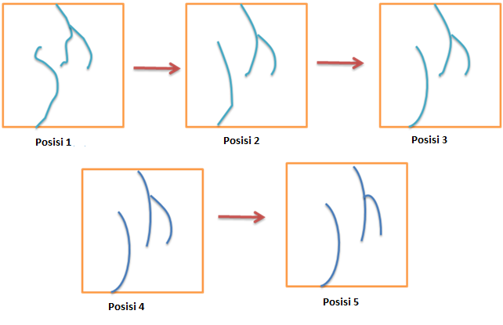
Figure 1. Illustrations of image acquisition with different position.
Figure 1 shows that image acquisition process with different position of palm geometry bring through error authentication. It is because different position of the same palm will consider as different palm.
Dataset used in this research is taken from Poly_U PalmPrint Database [9].
  - Pre-processing
Pre-processing begin by converting an RGB image into greyscale image, greyscale into binary, and then determine the ROI (Region of Interest). Figure 2 shows the implementation of morphology erosion and normalization of image intensity by ROI.

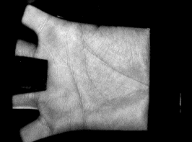

- (b)
Figure 2 (a) Raw Image, (b) Image after pre-processing
ROI result is very useful in feature extraction, because it is focused on the observed section which will be used in the next stage of image matching.
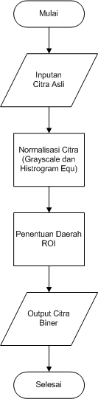
Figure 3. Pre-processing
Figure 3 describe the process of pre-processing to prepare input image by converting an RGB image, then image normalization and ROI determination to make binary image which then to be processed in feature extraction.
  - Feature Extraction
Feature extraction process by Multi-scale Wavelet Pyramid does not use optimum feature to set similarity value, so it is possibly an authentication error. Feature extraction will be applied multiple times until n level when the feature can not be extracted anymore to generate F₁, F₂, F₃, ….. F_{n}.
All processes above can be seen in figure 4. Figure 4 shows that feature extraction result 2 outputs, i.e. feature vector for multi-features from decomposition wavelet and optimum feature tested by n rotation.
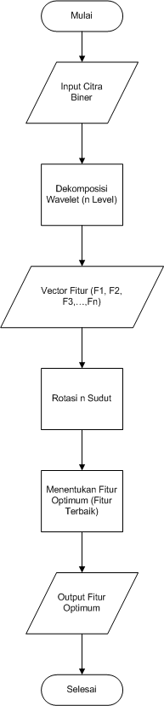
Figure 4. Feature extraction flowchart.
  - Determination of Optimum Feature
Optimum feature (F₀) is determined by test by assumptions as bellow :
- Image acquisitions with different angles to get a palm print (n kind of angles) [7-8]
- Feature extraction of each image by certain angles with Wavelet, so that we get n features (n dimensions).

  - Haming Distance
In this research, similarity level is measured by Haming Distance method. In this method, Euclidean distance is measured by comparing features of two images at the same position.

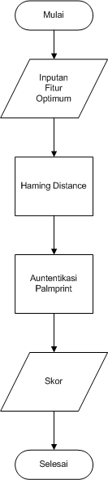
Figure 5. Authentication process of hand palm
Authentication process of palm print in figure 5 is not much different from pre-authentication process, especially in pre-processing stage. Feature extraction of palm print creates image dimension that can be assumed as dimension of pyramid to generate the optimum feature by wavelet of the image dimension. Then to calculate the similarity level of to get threshold value, so that image can be authenticated.
- Experiment
Some of scenario processes to get authentication result of highest accuracy palm print in shortest period, there are 2 experiments, i.e. training test and testing. The experiments have different treatment in feature extraction, it is the level used in measurement of similarity level in Haming Distance. First experiment uses whole levels (8levels), second experiment uses combination of level 1 and 2, meanwhile third experiment uses level 1, 2, and 3. The all three experiments are conducted to answer the purpose of MWP to create multi-scale or multi-dimensional image where in the process of testing is shown by combinations of several levels. This experiment is conducted by calculate authentication values of an image compared by 500 images in database.
All trials above use combination formulae of 1000 images of 50 samples (palm) from first acquisition (10 times) to be trained and second acquisition (10 times) to be tested. Each image will be treated similarly before calculating the Euclidean distance by image normalization, cropping the ROI, and convert into binary image. After that the converted image is extracted and then to calculate the distance. The accurate result of this tests is taken from percentage of best threshold value. While for time speed is determined by how many levels the image get through before the authentication.
In training test, the result is used to determine an optimum feature, i.e. the feature assumed as best feature with highest accuracy and shortest period. Optimum feature represents image feature of palm image to solve problem of hand palm image authentication.

2.1 Training Trial
In the training tests, there are 3 times tests in full level (8 levels), combination of level 1 and 2, and also combination of level 1, 2, and 3. Each test uses certain threshold value to get highest accuracy of 3 tests. Then, determination of best threshold values, the threshold with the best performance. Best threshold value will be reference in determination of optimum feature, which then used in testing.
Table 1
Result of Training Test Accuracy
Level | Threshold | Accuracy (%) | Period (Level)
Full Level (8 Level) | 4950 | 75.00 | 8
Level 1 and 2 | 4700 | 76.92 | 2
Level 1, 2 and 3 | 4920 | 76.78 | 3

2.2 Testing Trial
In testing trial, there are not many differences from training test. Testing is conducted with the same process in full level, combination of level 1 and 2, and combination oaf level 1, 2, and 3. But, in testing trial, threshold value is the best threshold value of each trial in training process. In trial of full level using threshold value of 4950, combination trial of level 1 and 2 or multi-scale 1 using threshold value of 4700, while in combination trial of level 1, 2, and 3 or multi-scale 2 using threshold value of 4920.

Table 2
Result of testing trial accuracy.
Level | Threshold | Accuracy (%) | Period (Level)
Full Level | 4950 | 74.28 | 8
Level 1 and 2 (Multiscale 1) | 4700 | 77.93 | 2
Level 1, 2, and 3 (Multiscale 2) | 4920 | 77.34 | 3

4. Conclusion
Based on the experiments can be concluded that Multi-scale Wavelet Pyramid is able to process the authentication of hand palm well that is 77.93% of accuracy in 4700 of threshold value and shortest period, only requires 2 times of transformation, in level 1 and 2(Optimum feature).
References

[1] D. Zhang, 2004.“Palmprint Authentication”, Kluwer Academic Publishers, USA.
[2] D. Zhang, W.K. Kong, J. You and M. Wong, Sept. 2003, “On-line palmprint identification”, IEEE Trans. on Pattern Analysis and Machine Intelligence, vol. 25, pp. 1041-1050.
[3] A. Kong and D. Zhang, 2004, “Competitive coding scheme for palmprint verification”, Proc. of International Conference on Pattern Recognition, vol. 1, pp. 520-523, Cambridge, UK.
[4] L. Zhang and D. Zhang, 2004, “Characterization of palmprints by wavelet signatures via directional context modeling”, IEEE Trans. on SMC-B, vol. 34, pp. 1335-1347, June 2004.
[5] Putra, Dharma, 2009. “Sistem Biometric (Konsep Dasar, Teknik Analisi Citra dan tahap Membangun Aplikasi Sistem Biometrika). Andi , Yogyakarta.
[6] Malik, J., Dahiya, R., Sayinarayan, G., 2011. Fast Complex Gabor Wavelet Based Palmprint Authentication . International Journal of Image Processing (IJIP), Volume (5) : Issue (3)
[7] Kokare, M., Biswas, P.K., Chatterji, B.N., 2007. Texture image retrieval using rotated wavelet filters. Pattern Recognition Letter, vol. 28, pp. 1240–1249
[8] Eka, R, Suciati, N, Wijaya, A. 2011. “Implementing Content Based Image Retrieval For Batik Using Rotated Wavelet Transform And Canberra Distance”, Bisstech.
[9]The PolyU Palmprint Database: http://www4.comp. polyu.edu.hk/biometrics/ (date download : Nov’ 2 2010)
[10] Ayuninghemi, Ratih, Zainal Arifin, A, Suciati, N. 2012. “Multiscale Wavelet Pyramid for Palmprint Image Aunthentication”. KNSI SIKOM BALI

